**Project Name Description *Software to Manage Continuous Improvement Suggestions***

**Prepared by: Date: *2017 09 10***

***Elizabeth Thomas***

***Indrajeet Mishra***

***Priyanka Sharma***

***Dhiksha Ramkumar***

***Sairam Rajagopalan***

**Objective:**  ***Create a web application that will provide a user with several song recommendations based on user history and popularity. The system will also maintain a database of users and song history.***

**Scope: *This will be addressed in the scope statement.***

**Assumptions:**

***We will be basing our system on a collection of music listening data, we will assume the software is designed in such as way as to work on top of a music listening system (from which the listening data would originate). Future modification may be needed to adapt the system to such an application.***

***In the event of the customer changing requirements, we would assume that best practices will be implemented to allow for the system to be updated to suite dynamic customer needs.***

**Schedule:**

***Date Focused Activities***

**9/5/2017 Preliminary Planning and Discussion**

**9/10/2017 Requirements Elicitation and Validation**

**9/20/2017 Creation of Design Diagrams**

**9/25/2017 Project Proposal Due**

**The project is planned in agile mode with 4 sprints into effect. The below image gives tasks created in each sprint and respective deadlines and assignee.**

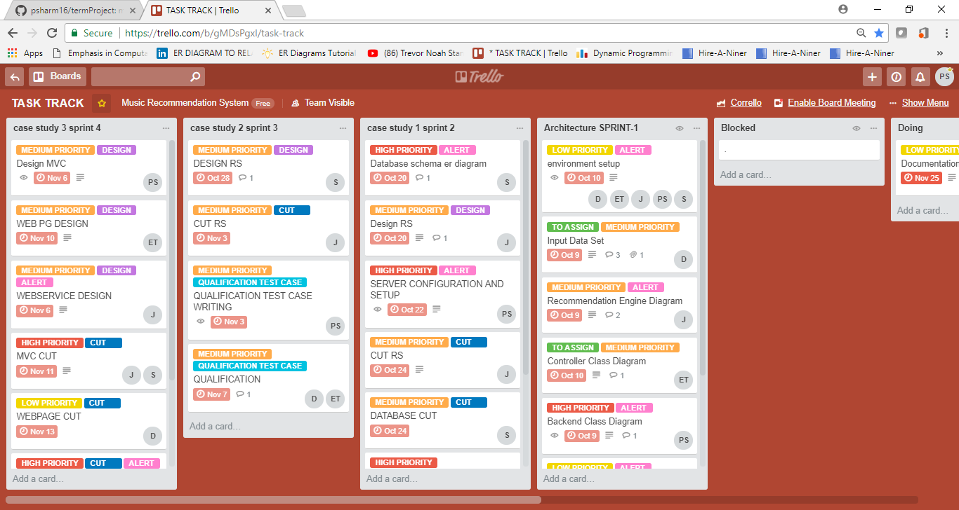

**11/26/2017 Project Due Date**

**\*\*Please refer to the Project_Schedule document for more detailed schedule information.**